Software SUPPORT ACTIVITY eSTABLIShMENT Process

PR-SPP-05 V1.0
April 18, 2002

System Engineering Process Office, 212
Space and Naval Warfare Systems Center
53560 Hull Street
San Diego CA 92152-5001

Approved for public release; distribution is unlimited
Preface

This document is to be used as guidance for establishing a Software Support Activity at the Space and Naval Warfare Systems Center, San Diego hereinafter referred to as SSC San Diego.
The SSC San Diego System Engineering Process Office (SEPO) assumes responsibility for this document and updates it as required to meet the needs of users within SSC San Diego. SEPO welcomes and solicits feedback from users of this document so that future revisions of this document will reflect improvements, based on organizational experience and lessons learned. SEPO makes copies of this document available on the SSC San Diego Process Asset Library (PAL) web-site at http://sepo.spawar.navy.mil.
Questions or comments regarding this document may be communicated to SEPO via the Document Change Request (DCR) form located at the back of this document.
RECORD OF CHANGES

*A - ADDED M - MODIFIED D - DELETED
VERSION  NUMBER | DATE | NUMBER OF FIGURE, TABLE OR PARAGRAPH | A*  M  D | TITLE OR BRIEF DESCRIPTION | CHANGE  REQUEST  NUMBER
TABLE OF CONTENTS
Section Page
Section 1. Introduction 1
1.1 Purpose 1
1.2 Background 1
1.3 Scope 1
1.4 Tailoring Guidelines 1
1.5 Document Overview 1
1.6 Reference Documents 2
1.7 Abbreviations, Acronyms and Terms 3
Section 2. Software SUPPORT ACTIVITY process definition 7
2.1 Implement Memorandum of Agreement (Step 1) 7
2.1.1 Purpose 7
2.1.2 Roles and Responsibilities 7
2.1.3 Entry Criteria 7
2.1.4 Input 8
2.1.5 Process Activity 8
2.1.6 Output 9
2.1.7 Exit Criteria 9
2.1.8 Process Metrics 9
2.2 Plan Transition (Step 2) 9
2.2.1 Purpose 9
2.2.2 Roles and Responsibilities 9
2.2.3 Entry Criteria 9
2.2.4 Input 9
2.2.5 Process Activity 10
2.2.6 Output 16
2.2.7 Exit Criteria 16
2.2.8 Process Metrics 16
2.3 Execute Plans (Step 3) 16
2.3.1 Purpose 16
2.3.2 Roles and Responsibilities 17
2.3.3 Entry Criteria 17
2.3.4 Input 17
2.3.5 Process Activity 17
2.3.6 Output 20
2.3.7 Exit Criteria 21
2.3.8 Process Metrics 21
2.4 Transition Project to Life Cycle Maintenance (Step 4) 21
2.4.1 Purpose 21
2.4.2 Roles and Responsibilities 21
2.4.3 Entry Criteria 21
2.4.4 Input 21
2.4.5 Process Activity 21
2.4.6 Output 22
2.4.7 Exit Criteria 22
2.4.8 Process Metrics 23
Appendix A. SAMPLE MEMORANDUM OF AGREEMENT DESIGNATING A SOFTWARE SUPPORT ACTIVITY A-1
Appendix B. SAMPLE COMPUTER RESOURCES WORKING GROUP CHARTER B-1

List of figures
Figure Page
Figure 1-1. The SSA Life Cycle Support Process 5
Figure 2-2. Peer Review Process 14
Figure 2-3. SSA Test Process 14
Figure 2-4. SSA Software Configuration Management Process 16
Figure 2-5. SSA Problem/Change Request Tracking 19
Figure 2-6. SSA SCM Baseline Library Contents 20

This page intentionally left blank.

Section 1. Introduction

1.1 Purpose
The purpose of this document is to serve as a guide to successfully establish a Software Support Activity (SSA) for system software within the Space & Naval Warfare (SPAWAR) System Center (SSC) San Diego organizational structure. An SSA assumes the role of providing post-deployment life cycle support for modifications or upgrades made to a system's software following the system's initial fielding. In providing the following guidance, it is assumed that the reader is familiar with “A Description of the SSC San Diego Software Process Assets (SPA)”, reference (a).

Background
This document addresses the activities leading to the establishment of an SSA capability supporting post-deployment of system software. In this context, system modifications and upgrades include multi-system changes, block changes, preplanned product improvements, repair of deficiencies reported by the user, and other types of system change packages. These activities will be referred to as Life Cycle Support (LCS) in the balance of this document.
The SSA environment generally manages a series of functional changes and repair over a period of time. The SSA organization typically collects these needed updates into a few formal software releases to avoid disrupting the fielded system. Software development activities performed by an SSA in providing LCS are the same as those carried out during the development effort that led to the first fielding. They are tailored, as appropriate, to reflect the effort required to implement each change package, update pertinent documentation, verify the changes, and distribute the changes to users. Figure 1-1, located at the end of this section, illustrates the many activities that must be planned and coordinated to provide LCS to fielded systems.

1.3 Scope
Guidance contained in this document applies to planning by all levels of management involved in efforts to establish an SSA within the SSC San Diego organization for a project transitioning to life cycle support.

1.4 Tailoring Guidelines
Tailoring of this document is permitted. Tailoring should follow the directions contained the SPA document. Comments on these guidelines may be submitted using the Document Change Request (DCR) form at the end of this document.

1.5 Document Overview
This document addresses steps and guidelines for establishing an LCS capability. Section 1 provides background information. Section 2 provides detailed information on each step of the process. The following list provides the format used to describe each of the process steps in Section 2:
- PURPOSE: The objective of the process activity. If a sub-process activity exists, the details are described in that specific paragraph description.
- ROLES AND RESPONSIBILITIES: The responsibilities of individuals or groups for accomplishing a process activity.
- ENTRY CRITERIA: The elements and conditions necessary to be in place to begin a process activity. Reading lower level activities assumes that the entry criteria for all higher level activities have been satisfied.
- INPUT: Data or material with which a process activity is performed.
- PROCESS ACTIVITY: Actions to transform an input, as influenced by controls, into a predetermined output.
- OUTPUT: Data or material produced by or resulting from a process activity. It must include the input data in some form. The output title differs from the input title to indicate that an activity has been performed.
- EXIT CRITERIA: Elements and/or conditions necessary to be in place to complete a process activity.
- PROCESS METRICS: Data collected which can be analyzed and used to improve the process.

1.6 Reference Documents
The following documents, available from the SSC San Diego Process Asset Library (PAL) at http://sepo.spawar.navy.mil, are either referenced in this document or were used to create it:
- A Description of the SSC San Diego Software Process Assets
- SSC San Diego Policy for Software Project Planning
- SPAWARSYSCEN San Diego Instruction 5234.1, Software Engineering Process Policy
- Requirements Management Guidebook
- Software Project Planning Process
- Software Estimation Process
- Software Configuration Management Process
- Peer Review Process
- Software Project Tracking and Oversight Process
- Software Quality Assurance Process
- Software Development Plan Template
- SSC San Diego Software Engineering Training Plan
- Organization Project Management Plan Template
- Organization Measurement Guide
- Risk Management Process
- Integrated Software Management/Software Product Engineering/Inter-group Coordination (ISM/SPE/IC) Implementation Guide
- Software Management for Executives Guidebook
- Contractor Acquisition and Performance Monitoring Process
- MIL-STD-498, Software Development and Documentation, 5 December 1994
- Capability Maturity Model for Software V1.1

1.7 Abbreviations, Acronyms and Terms
CAPM Contractor Acquisition and Performance Monitoring
CASE Computer-Aided Software Engineering
CCB Configuration Control Board
CMM Capability Maturity Model
CRLCMP Computer Resources Life Cycle Management Plan
CRWG Computer Resources Working Group
DCR Document Change Request
FCA Functional Configuration Audit
IC Inter-group Coordination
IDTC Indefinite Delivery order Type Contract
IPT Integrated Product Team
ISM Integrated Software Management
IV&V Independent Verification and Validation
KPA Key Process Area
LCCB Local Configuration Control Board
LCS Life Cycle Support
MOA Memorandum of Agreement
MIL-STD Military Standard
PAL Process Asset Library
P/CR Problem/Change Request
PDF Project Data Form
PCA Physical Configuration Audit
PRP Procurement Requirements Package
RFP Request For Proposal
OPMP Organization Project Management Plan
OPNAV Office of the Chief of Naval Operations
OSPD Organization Software Process Database
SCCB System Configuration Control Board
SCM Software Configuration Management
SCMP Software Configuration Management Plan
SDL Software Development Library
SDP Software Development Plan
SEPO Software Engineering Process Office
SSC SPAWAR Systems Center
SPA A Description of SSC San Diego Software Process Assets document
SPAWAR Space and Naval Warfare
SPE Software Product Engineering
SPM Software Project Manager
SPP Software Project Planning
SPTO Software Project Tracking and Oversight
SQA Software Quality Assurance
SQAP Software Quality Assurance Plan
SSA Software Support Activity
STrP Software Transition Plan
TRB Technical Review Board
WBS Work Breakdown Structure
Figure 1-1. The SSA Life Cycle Support Process

This page intentionally left blank.

Section 2. Software SUPPORT ACTIVITY process definition
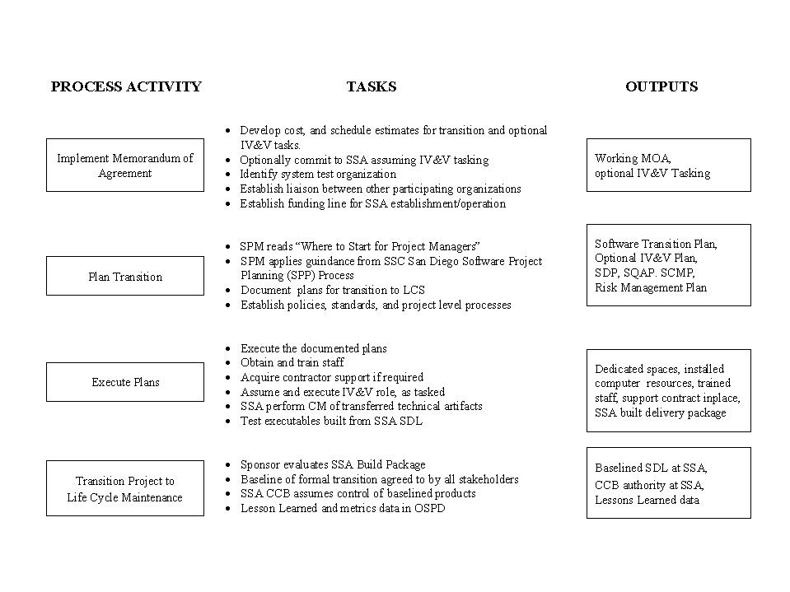
Figure 2-1. Establishing an SSA

2.1 Implement Memorandum of Agreement (Step 1)

2.1.1 Purpose
The purpose of the first process activity in Figure 2-1 is to initiate the transition of a project from the development activity to SSC San Diego as the SSA for LCS in accordance with a Memorandum of Agreement (MOA). See Appendix A, for a sample MOA.

2.1.2 Roles and Responsibilities
The candidate SSA Software Project Manager (SPM) is responsible for carrying out this process step.

2.1.3 Entry Criteria
The entry criteria for this step are listed below:
- An opportunity has been identified by a current business area manager, i.e. Department Head, Division Head, or a current SPM.
- The business area manager has fostered a relationship with the new system’s sponsoring agency and has assumed the role of SSA SPM.
- The candidate system’s life cycle has both the potential for longevity and commitment from higher levels of Navy management, i.e., Office of the Chief of Naval Operations (OPNAV).
- The sponsor and SSC San Diego senior management have signed an MOA designating SSC San Diego as the SSA. A sample MOA is contained in Appendix A.

2.1.4 Input
Inputs to this step are listed below:
- SSC San Diego Software Engineering Process Policy
- Signed MOA designating SSC San Diego as the SSA
- SSC San Diego SPA document.

2.1.5 Process Activity
There are five major activities involved in implementing the MOA. These are addressed in the following paragraphs.
2.1.5.1 Develop Cost and Schedule Estimates for Transition and Optional IV&V Tasks. The SSC San Diego SSA SPM should be involved early, even prior to the signing of the MOA, with the sponsor to have the opportunity to participate in the development of cost estimates for the transition, optional Independent Verification and Validation (IV&V) tasks, and the subsequent LCS. The estimation efforts for each activity needs to address multi-year budgets that would include estimates for equipment, staff, travel, facilities and support software purchase and/or development (e.g., test tools, operating systems, management tools).
2.1.5.2 Optionally Commit SSA to Assuming IV&V Tasking. As an option, the SSA SPM and the sponsor should agree to the SSA performing the role of IV&V Agent. This presents an opportunity for economy in that the funds and tasking that are required for IV&V would also support the development of the SSA’s infrastructure and educate the staff on the technical details of the emerging system. This dual role will help provide a seamless transition from the development organization to the SSA.
2.1.5.3 Identify System Test Organization. Discussion with the sponsor should lead to an understanding of the test processes required to field an operational quality system. Part of this process is the validation and verification services provided by a system test organization that is organizationally separate from both the development agency and the designated SSA. The sponsor will make these decisions with consultation from the designated SSA SPM.
2.1.5.4 Establish Liaison With all Other Participating Activities. Important to planning the LCS effort is an understanding of the need of the operational users for functional enhancements and repair of system problems. Newly fielded systems typically have a backlog of functional requirements that need to be delivered in future revisions. However, operational requirements and installation coordination will need to be analyzed to determine the optimum revision cycle. Systems with a large user community require considerable coordination to synchronize formal testing, installation, and the system ‘Turn On’ times. Consequently, cycles of nine months to a year or more are not atypical. Systems with smaller user communities will be able to shorten this window. The sponsor and SSA SPM, working with representatives from the user community should establish a revision cycle that is feasible in the context of required system reliability, installation, and operational necessity.
In preparation for supporting a user community, the SSA SPM should ensure that boards and working groups that would be used to allow the system stakeholders, including user representatives, to have a voice, are defined. Examples would include the Computer Resources Working Group (CRWG). A sample charter for such an organization is included in Appendix B to this document.
2.1.5.5 Establish Funding Line for SSA Establishment/Operation. The sponsor, having committed to SSC San Diego as the SSA, will formally establish a multi-year budget line within the sponsor’s organization to support the transition, IV&V effort, and LCS effort. The budget line should be approved by the sponsor’s parent organization to ensure the future of the LCS effort. The sponsor establishing the budget line demonstrates the level of commitment needed to warrant further investment by SSC San Diego for the long-term LCS effort.

2.1.6 Output
The outputs from this step are listed below:
- Initiation of the activities agreed to in the MOA
- Working multi-year budgets for transition, LCS, and optional IV&V tasks
- Established budget line at the sponsor level to support future tasking.

2.1.7 Exit Criteria
Commitment has been achieved as demonstrated by the sponsor, SSC San Diego, and other cognizant organization representatives initiating the activities supporting the MOA and an established budget line to support future work effort.

2.1.8 Process Metrics
Metrics collected for this step include the effort and costs expended in initiating the MOA.

Plan Transition (Step 2)

2.2.1 Purpose
The purpose of the second process activity in Figure 2-1 is to perform the planning functions needed to transition a project from the development activity to SSC San Diego as the SSA for LCS in accordance with the MOA.

2.2.2 Roles and Responsibilities
The program sponsor, SSA SPM, and SSC San Diego senior management are responsible for the activities associated with software transition planning.

2.2.3 Entry Criteria
Signed MOA and an established budget line at the sponsor’s level to support the transition and subsequent LCS effort.

2.2.4 Input
The inputs to this step are listed below:
- Signed MOA
- Detailed estimate used to establish the budget line for transition and LCS
- Operational system requirements
- Computer Resources Life Cycle Management Plan (CRLCMP) if available
- Organization Program Management Plan (OPMP) if available
- Development activity’s development plans such as the Software Development Plan (SDP), Software Configuration Management Plan (SCMP) and Software Quality Assurance Plan (SQAP)
- Development activity’s software engineering environment specifications
- Current test environment requirements and specifications.

2.2.5 Process Activity
There are four activities involved in planning the transition. These are addressed in the following paragraphs.
2.2.5.1 SPM Reads “Where to Start for Project Managers”. The “Where to Start for Project Managers” on the SSC San Diego PAL at http://sepo.spawar.navy.mil/ will introduce the SSA SPM to assets available to help in establishing a LCS capability. The SPA, reference (a), contains comprehensive information on the full scope of available software engineering assets. The appendices to the SPA provide an outline of the information all software management professionals should understand prior to leading a project. Appendix A addresses essential topics about the SSC San Diego business environment. Following that are guidelines for taking over an existing project or beginning a new project. Appendix B presents a synopsis of a software project manager’s responsibilities from the perspective of key management activities.
2.2.5.2 SPM Applies Guidance from SSC San Diego Software Project Planning Process. The planning phase is one of the most crucial steps in any software development project. Before starting the planning activities, the SPM should become familiar with the “SSC San Diego Policy for Software Project Planning”. The Software Project Planning (SPP) Process is available at http://sepo.spawar.navy.mil/ by selecting “Processes by CMM KPA for downloading” on the SSC San Diego PAL and then “Software Project Planning”. The SSA SPM will be aided in his planning effort by the guidance contained in the process document. Issues to address would include, but not be limited to those listed below:
- Establish reporting responsibilities
In planning for the SSA effort, the SSC San Diego responsible manager should refer to the OPMP. This document provides a template for an overall plan and provides a framework for further planning efforts. The document can be used as a proposal vehicle to communicate to the sponsor and user community representatives that SSC San Diego has the organization, capabilities, and resources to assume the role of SSA. In developing an OPMP, an initial definition of the organizational chain of command necessary for the SSA effort should be documented. This chain of command should flow from the sponsor to the respective SSC San Diego entities that will form the SSA.
- Define roles and responsibilities for SSA effort
A proposed set of roles and responsibilities for key positions, boards and working groups should then be determined. Positions to address include the requirements management, development, test, software quality assurance, configuration management, and staff support to the SSA SPM. The tools to be used to support the management of the SSA organization should be identified. This would include tools for financial, documentation, configuration management, and metrics support.
- Define facilities requirements
The requirements for SSA facilities at SSC San Diego need to be analyzed and defined. These facilities may include special buildings, rooms, mock-ups, building features such as raised flooring or cabling, hardware, network equipment, software requirements such as operation systems and software tools, and building features to support security and privacy requirements (TEMPEST shielding, vaults, etc.). In addition, building features to support safety requirements (smoke alarms, safety glass, etc.), special power requirements, and so on need to be addressed. Installation plans also need to be developed.
System security issues are also a key part of both the transition and the software engineering environment. The transition effort should include tasks that satisfy the security requirements for the system. Security requirements can range from the physical security of the space and lab environments to issues of multi-level security certification for the operating system supporting the software engineering tools. Any tasks concerned with receiving formal security certificates should be included in the software transition plan and the cost, schedule, and effort tracked to completion.
- Identify documentation set, format and content standards, and media
The transition effort should include the identification of system-related documentation that is required to support the system software during its life cycle. The list would include plans, reports, studies, specifications, design descriptions, test cases/ procedures, test reports, user/operator manuals, and support manuals for the software targeted for LCS. In addition, the format standard that applies to each document should be defined as should be any unique form or media for maintaining the information. The current state of the format and content of documentation held by the development activity should be considered in determining LCS documentation requirements.
- Determine staff/contractor requirements
The requirements for the knowledge, skills, and abilities for each needed staff position should be defined. The SSA SPM will need to determine if these needs can be met by recruiting from existing SSC San Diego resources and/or consider the need to acquire contractor support. If it is determined that contractor support is required, then an acquisition strategy must be determined. Alternative approaches for acquiring contractor support include:
  - Initiate New Contract Package. Choose the contract type, e.g. Indefinite Delivery Order Type Contract (IDTC), Cost Plus Fixed Fee, Completion type, Fixed Price, Small Business, etc. The SSC San Diego Contracting Officer will assist with this determination although most software support contracts are the IDTC type. Develop and track a Plan of Action and Milestones for generating and processing a Procurement Requirements Package (PRP), the subsequent Request For Proposal (RFP), and through final award. This plan should be included as a sub-task in the software transition plan’s supporting Microsoft Project plan.
  - Initiate a Delivery Order Package. If a contract vehicle already exists, the SSA SPM can determine if a desired delivery order is within scope, schedule, and ceilings of an existing basic contract (IDTC).
  - Modifying an existing contract or delivery order. If a current contract vehicle can be adapted to the SSA requirements then the SSA SPM can determine the contract area requiring modification. Modifications are necessary whenever there are changes to scope, requirements, deliverables, schedule, costs, or funding.
2.2.5.3 Document Plans for Transition to LCS. The results of the planning process need to be documented and a commitment made to those plans by the sponsor and SSC San Diego. Three key activities for documenting software transition plans would include, but not necessarily be limited to those listed below:
- Document the project life cycle support organization, facilities, staffing requirements, etc.
In planning for the SSA effort, the SSC San Diego responsible manager should refer to the OPMP. This document provides a template for an overall plan and provides a framework for further planning efforts. The document can be used as a proposal vehicle to communicate to the sponsor and user community representatives that SSC San Diego has the organization, capabilities, and resources to assume the role of SSA. The document includes the LCS chain of command from the sponsor to the SSC San Diego entities that form the SSA and defines the roles and responsibilities for the key position within the SSA. Items addressed include the requirements management, development, test, software quality assurance, configuration management, and staff support to the SSA SPM. In addition, the tools to be used to support the management of the SSA organization are identified. This would include tools for financial, documentation, configuration management, and metrics support.
- Document Software Transition Plan
A Software Transition Plan (STrP) Template based on MIL-STD-498 is available from the SSC San Diego PAL under the SPP Key Process Area (KPA). A software transition plan should include, in addition to the software support resources, details such as effort, cost and schedule, of the transition from the development activity to SSC San Diego. Section 7 of the software transition plan should contain detailed tasking in a Work Breakdown Structure (WBS) format for tasks, cost, schedule, milestones, and effort. These activities may include planning/ coordination meetings; preparation of items to be delivered to the support agency; packaging, shipment, installation, and checkout of the software support environment; packaging, shipment, installation, and checkout of the operational software; and training of support personnel.
Microsoft Project is an example of a tool that can be used to define the plan in terms of tasks, cost, schedule, and effort for the transition. Reports generated from the tool can satisfy many of the requirements for the needs of Section 7 of the software transition plan and facilitates the needed management tracking and control.
- Document IV&V Plan, if needed.
If the SSA is to perform as the IV&V agent, an IV&V plan should be developed with its own specific WBS and associated cost, schedule, and resource requirements specified. Examples of an IV&V plan can be obtained from the Systems Engineering Process Office (SEPO) Library.
- Document Transition Risk Management Plan
An initial risk assessment for the transition effort should be performed and included with the software transition plan. A plan to mitigate and handle contingency should be developed. Sample Risk Management Plans are available from the SEPO library, illustrating ‘Best Practices’ in risk management at SSC San Diego. In addition, the SSC San Diego PAL has a Risk Management Process document available for download and tailoring.
2.2.5.4 Establish Policies, Standards, and Project-Level Processes. The purpose of this activity is to establish policies, select standards and develop the planning documents for the LCS of the system software. These policies, standards, and plans may have been completed by the development activity and be available for tailoring to the SSC San Diego SSA organization. The Software Development Plan (SDP) is an example of a key document that guides the life cycle support effort. The organization’s standard software process is a major input to the SDP. Therefore, the project manager should review the SPA document for further guidance on planning the software project. The SPA contains a description of the SSC San Diego standard software process; a description of the approved software life cycle strategies; tailoring guidance; a description of the SSC San Diego Organization Software Process Database (OSPD); and a description of the other SSC San Diego process assets available from the SSC San Diego PAL. Activities involved are listed below:
- Tailor organizational standard processes to project
The processes and templates available on the SSC San Diego PAL are tailored, incorporating the findings of the planning activities above into project-specific drafts for the processes supporting planning, project tracking and oversight, sub-contractor management, etc. These documents are subject to a peer review process as described in the “Peer Review Process” document available on the SSC San Diego PAL under the Peer Reviews KPA. The process documents are placed under configuration control once approved.
- Develop project-level plans
In this step, the SSA team needs to review the SPA document and become familiar with the SDP SCMP, SQAP, and Risk Management Plan templates from the SSC San Diego PAL. Tailoring the SDP template will require addressing the following items:
- Scope/Objective/Goals – refer to the Computer Resources Life Cycle Management Plan (CRLCMP) or MOA.
- Project Organization – refer to the OPMP developed to help ensure SSC San Diego as the SSA.
- Task Definition - Refine the major tasks to maintain the software (e.g., software design, software test, independent verification and validation). This can be accomplished using a work breakdown structure format.
- Schedule - Refine the project's overall schedule and the schedules associated with each task including significant events (reviews, audits, and key meetings) related to the task and interdependencies with other tasks. Refer to the previously developed Software transition plan cost, schedule, and effort data. Project management tools, such as Microsoft Project may be used to develop and manage the LCS project schedule and resources. A project template is available from the SSC San Diego PAL.
- Cost - Refine the cost for the software project. The cost should be expressed as a total cost throughout the life of the project and as yearly cost for multi-year projects. Refer to the “Software Estimation Process” document for procedures to develop the cost.
- Resource Requirements – Refine any personnel, software and hardware resources and any limiting factors associated with each resource (e.g., dates available, skill type, and sequences of events and dependencies). Refer to the “Software Estimation Process” for further discussion on critical computer resource estimation.
- Software Processes – Document the techniques, methodologies and tools for the development and control of the software through all its development phases (e.g., preliminary design, detailed design, implementation, integration, testing, internal/external reviews, inspections, corrective action process, problem/change reports, software product evaluation). The project’s defined software process should be tailored to conform to the organization standard software process. The processes may be derived from the development activity’s processes or from those contained in the SSC San Diego PAL. Refer to the SPA for process tailoring guidelines. The project’s defined software processes will be managed and controlled. Figure 2-2 is an illustration of one of the processes to be documented.
- Software Standards - Identify the standards and procedures that will be used for maintenance of the software product(s) including language-specific standards, the contents and maintenance of the software development files.
- Software Development Environment/Software Test Environment - Document the software development and test environments identified when facilities were defined for the LCS effort. Figure 2-3 illustrates a test process typical of that required to support the LCS effort.
Figure 2-2. Peer Review Process
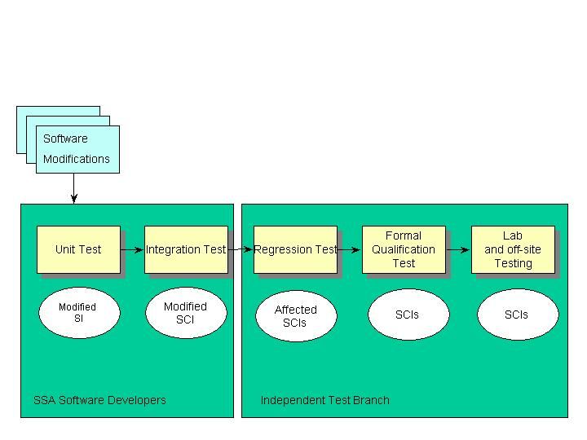
Figure 2-3. SSA Test Process
- Software Licenses - Document all software license agreements such as those associated with the software development environment, software test environment, target environment, and the maintenance environment. In addition, note the licenses associated with software packages delivered to the customer.
- Documentation - Identify the documentation standard or the format required to transition the developer’s documentation into a working media within the SSA.
- Training – Document training needs identified when developing the SSA staffing requirements. Identify the training requirements for the customer to effectively use the delivered software. A good source could be the training plans of the development activity. Refer to the “SSC San Diego Training Program Policy” and the “SSC San Diego Software Engineering Training Plan” for further guidance.
- Project Constraints - Identify the constraints that will impact meeting the sponsor and operational user’s needs (i.e., start date, completion date, specific tools, software development environment, software test environment, availability of tools or environments, resources, and dependencies on external activities relating to project commitments). This information may be reflected in the tasking statement received from the sponsor or from information received from a CRWG, Integrated Product Team (IPT), or Technical Review Board (TRB) that may be providing technical inputs to the project.
- SQA - Document the organization's structure and personnel resources for performing Software Quality Assurance (SQA) activities on the software products produced for the customer and the SQA activities for evaluating the software engineering or development processes. Define the approach for evaluating the software and associated documentation, the software engineering processes, and identify the tools utilized by the SQA group. Refer to the “Software Quality Assurance Process” document and associated SQAP template. Alternatively this information can be included in the SDP.
- Configuration Management - Document the organization's structure and personnel resources for performing software configuration management for the software developed or used throughout the project. Define the configuration control flow used for changes to software and documentation and deliveries of products. In addition, the configuration management tasks would include tracking the configurations, hardware and software, at each supported site and the conduct of deliveries. Refer to the “Software Configuration Management (SCM) Process” document and associated templates for further details. Figure 2-4 illustrates the issues to be addressed in a SCM process.
- Security - Identify the security levels of any facility used on the project. Identify any classified processing or security issues associated with software items (e.g., tool), firmware and hardware.
- Develop Risk Management Plan for LCS effort
Refine the risks in the software project by utilizing a risk analysis method which provides risk identification, risk factors, risk assessment, risk prioritization, risk management strategies, risk resolution, risk monitoring techniques and document the contingency procedures for each area of risk on the project. This can be a refinement of the original risk analysis provided by the development activity and as found in the OPMP. Refer to the “Risk Management Process” document in the SSC San Diego PAL.
A plan to mitigate risks and to handle contingencies, should mitigation fail, should be developed. Sample Risk Management Plans are available from the SEPO library, illustrating ‘Best Practices’ in risk management at SSC San Diego.
Figure 2-4. SSA Software Configuration Management Process

2.2.6 Output
The outputs from this step are the required project-level planning documents (Software transition plan, LCS SDP, SCMP, SQAP, Risk Management Plans, and IV&V plan) and refined estimates for the work effort.

2.2.7 Exit Criteria
A commitment from both SSC San Diego senior management and the sponsor to the transition, optional IV&V plan, and LCS planning documents. Commitment is performed through the signature page for the respective documents.

2.2.8 Process Metrics
Metrics collected for this step includes the effort expended in planning work efforts.

2.3 Execute Plans (Step 3)

2.3.1 Purpose
The purpose of the third process activity in Figure 2-1 is to execute the plans developed for the transition of a project from the development activity to SSC San Diego as the SSA for LCS.

2.3.2 Roles and Responsibilities
The SSA SPM, senior management, software maintenance lead, program sponsor, project personnel, software test lead, SCM, SQA, development activity representatives, and the CRWG all play a role in executing the plans needed to effect a transfer of responsibility for LCS from the development activity to the SSA.

2.3.3 Entry Criteria
SSC San Diego senior management and the sponsor have made a formal commitment to the LCS approach defined in the OPMP. The sponsor working with SSC San Diego’s SSA SPM, the CRWG/IPT/ TRB, and the development agency have established a timeframe for the transition from the development activity to the SSA. The software transition plan and all LCS planning documents have been agreed to and baselined.

2.3.4 Input
The Software transition plan and the draft planning documents such as the SDP, SCMP, SQAP, Risk Management Plan, and optional IV&V plan. In addition, higher-level documents such as the CRLCMP, OPMP, System and software requirements, and CRWG recommendations will provide further guidance.

2.3.5 Process Activity
There are six major activities involved with executing the plans for transition. These are addressed in the following paragraphs.
2.3.5.1 Execute the Hardware/Software Acquisition Plans. The software transition plan should include the tasks, with cost and schedule, that are required to acquire the needed hardware suites and software packages that define the software engineering environment. The hardware may include computers, peripheral equipment, hardware simulators, stimulators, emulators, diagnostic equipment, network hardware/software, and non-computer equipment. The software may include Computer-Aided Software Engineering (CASE) tools, data in these tools, compilers, test tools, test data, simulations, emulators, utilities, configuration management tools, databases and data files, and other software.
Included in the software transition plan should be the starting of activities defined in the LCS planning documents such as the SDP, SCMP, and SQAP. This will serve to initiate the LCS capability within the SSA organization.
2.3.5.2 Obtain and Train Staff. With the organizational structure of the SSA defined in documents such as the OPMP, there is still a need for further refinement to determine the size of each team within the staff and the knowledge, skills, and abilities needed for each position. The first task will be to assign the key SSA leadership positions, such as those listed below:
- Software Configuration Manager
- Software Development Lead
- Financial/Data Analyst
- Software Quality Assurance Manager
- Software Test Lead.
This team leadership core will then refine the staffing requirements. The effort will include defining the personnel needed to support the deliverable software, including anticipated number of personnel by labor category, types, project related experience, and levels of skills, and security clearances.
With the detailed knowledge, skills, and abilities for each staff position defined, the SSA leadership team will recruit from existing SSC San Diego resources and/or consider the need to acquire contractor support.
Filling the individual positions within the staffing structure will require analyzing the candidates on the basis of the following criteria:
- Software project management and/or technical skills
- Familiarity with the organization standard software process and how to tailor and/or apply it.
- Team skills
- Knowledge in the project technical domain.
As the SSA staff is brought together, training will be required to develop the skills and knowledge of individuals necessary to develop, implement, and support the system. In addition, training is needed to develop the professional excellence of employees to perform their roles more effectively and efficiently. While training is an organizational responsibility, the software project manager has the task of identifying the staff’s needed skills and providing the necessary training. A good point of reference could be the training plans from the development activity. Activities supporting training would include, but not be limited to those listed below:
- Conduct training needs analysis
- Create Training Plan
- Design curriculum
- Create/update/acquire training materials
- Pilot and deliver training
- Evaluate delivered training
- Maintain training records.
For additional guidance refer to the “SEPO Training Program Process” available on the SSC San Diego PAL under the Training Program KPA.
2.3.5.3 Acquire Contractor Support, if required. The SSA SPM and his supporting team leaders should analyze whether the tasks can be performed with personnel available from within SSC San Diego or if a contractor’s support will be required. If it is determined that contractor support is required, then an acquisition strategy must be determined. Refer to the “Contractor Acquisition and Performance Monitoring Process” available from the SEPO PAL under the “Software Subcontractor Management” KPA for additional guidance on acquiring and managing a support contractor.
2.3.5.4 Assume and Execute IV&V Role, as Tasked. During the transition phase, the SSA serving in this capacity provides a cost benefit as well as allowing the SSA to develop the required knowledge for the LCS effort. IV&V is the systematic evaluation of a computer program and associated products by an agent independent of the developer. The SSA will execute the IV&V plan as tasked by the sponsor. This typically involves assessing overall program development quality and status. Since the IV&V team uses developer products as the objects of analysis and testing, they will become aware of delivery schedule impacts, non-delivered items needed for software support, and overall development product quality. IV&V reports its assessment, along with the analysis and independent testing results, to help provide the sponsor the development activity insight and control of the program development. The IV&V effort should be tracked in a Microsoft Project Plan focused specifically on the tasks, cost, schedule, and effort associated with the IV&V effort.
2.3.5.5 SSA Perform CM of Transferred Technical Artifacts. To ensure a successful transition from the development activity to the SSA requires a SCM environment capable of accepting the documentation, processes, and software artifacts that are required for LCS. To that end, the required computer resources and software tools need to be validated. Further, the SSA’s Local Configuration Control Board (LCCB) needs to be established and operating to verify its readiness for SSA responsibilities.
Figure 2-5 depicts a status accounting cycle that requires automated tools. The Software transition plan will contain an initial assessment of tools to support the overall software engineering environment. The tools specific to supporting both the status accounting and the Software Development Library (SDL) will need to be validated. The SSA parent organization may well have an existing configuration management tool suite and process that needs to be interfaced to or may well supplant the tools that have been currently identified. Tool selection has to provide a seamless transfer of status accounting database and SDL from the development agency to the SSA hardware/software tool set.
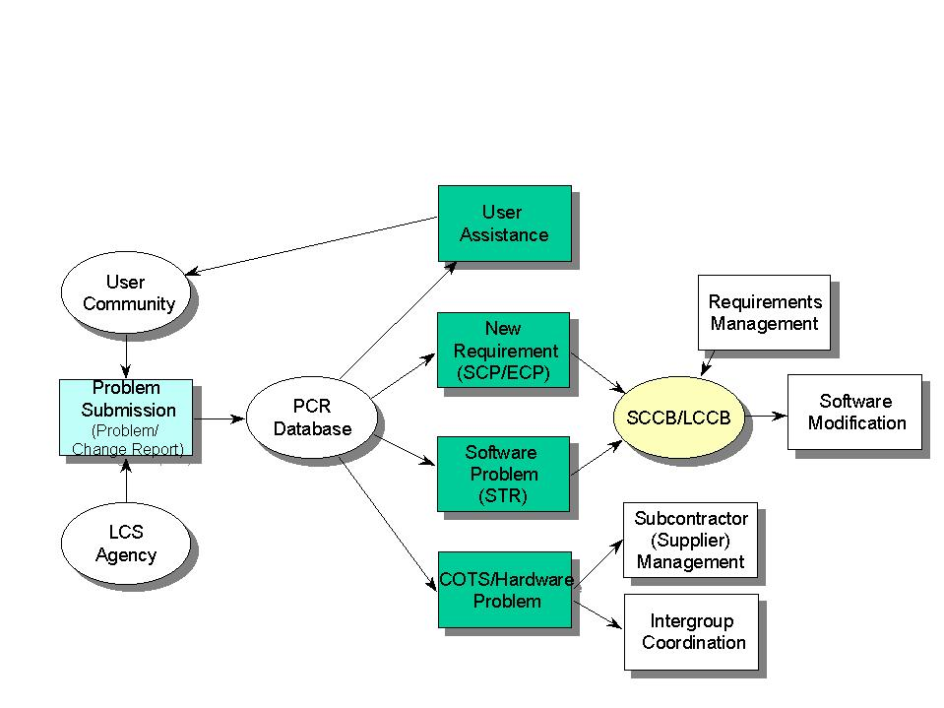
Figure 2-5. SSA Problem/Change Request Tracking

Figure 2-6 addresses the key artifacts from the developer’s environment needed to populate the SSA configuration management database.
Validating the SCM databases involves loading the system with sample status accounting and SDL data. The SCM hardware/software suite and the operation of the LCCB is then previewed to validated that it is ready to perform its tasks during LCS of the system software.
The LCCB should be activated as soon as the SCM hardware/software suite is ready to be validated. The board would work in an advisory capacity until the formal transition. This will allow the SSA to become intimate in the status of the baselined products and serve to verify internal SCM procedures.
2.3.5.6 Test Executables Built from SSA SDL. In addition to verifying the operation of the configuration management disciplines, there is a need to verify the SSA’s capability to build and test an operational system. Using the artifacts placed under configuration control, after transfer from the development activity, the SSA team will build and test a revision of the software system. This will verify the SSA’s ability to configure a deliverable and the test environment, including the test bed that has been placed under configuration control by the SSA. The SSA will make an assessment as to readiness of their build for certification by an external agency.

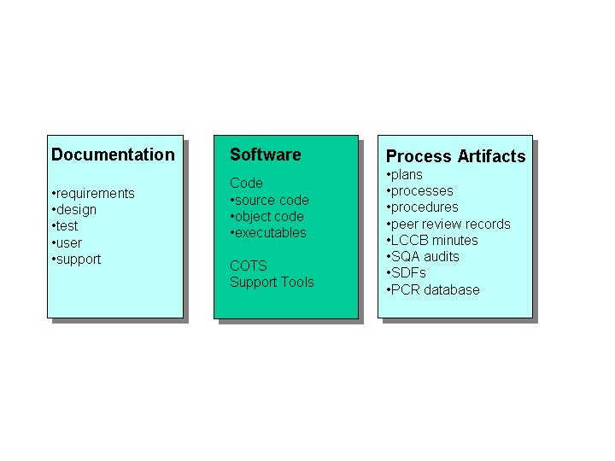
Figure 2-6. SSA SCM Baseline Library Contents

2.3.6 Output
The outputs of this step are listed below:
- Updated and approved LCS planning documents such as the SDP, SCMP, SQAP, and Risk Management Plan. A plan for the initial revision of the project software by the SSA has been developed and approved by the sponsor.
- Facilities for the conduct of LCS are operational within the SSA environment, the LCS staff is in place, the SSA’s LCCB is verified as ready to assume its role, and the SSA’s SDL is under configuration control.
- A delivery package, ready for certification, has been built and tested by the SSA.

2.3.7 Exit Criteria
Secure facilities and computer resources are operational within the SSA organization. The organization is fully staffed with knowledgeable trained professionals. A project plan has been baselined for the initial revision to be performed by the SSA.
The SSA’s SCM system and LCCB has been verified as ready to assume status accounting and SDL baseline control functions by the SSA team, the sponsor, the CRWG/IPT/TRB, and the development activity.
A delivery package has been prepared by the SSA from its SDL and is ready for certification.

2.3.8 Process Metrics
Metrics collected for this step includes the effort expended and percent complete of the task defined in the Microsoft Project representation of the Software transition plan. Earned Value calculations should be used to track progress.

Transition Project to Life Cycle Maintenance (Step 4)

2.4.1 Purpose
The purpose of the final process activity in Figure 2-1 is to perform a seamless transfer of responsibility for the system software from the development activity to the SSA. This step involves validating the SSA’s ability to support the system software engineering activities required for LCS and then executing the formal transition of responsibilities. The SSA LCCB assumes the primary role in support of the sponsor’s SCCB. With the approval of all stakeholders, a formal letter/message of the effective date of the SSA assuming responsibility is issued.

2.4.2 Roles and Responsibilities
SSA SPM, SSC San Diego senior management, software maintenance lead, program sponsor, project personnel, software system test lead, SCM, SQA, the CRWG, current development activity representatives and other affected groups are responsible for a formal commitment to finalizing the transition.

2.4.3 Entry Criteria
The SSA software environments for development, test, and SCM have been verified as operationally ready. The SSA’s LCCB is ready to assume status accounting and baseline control functions. The SSA-generated delivery package is ready for certification. The LCS planning documents such as the SDP, SCMP, SQAP, and Risk Management Plan have been approved. The sponsor has approved the transition of SCM control from the development activity to the SSA.

2.4.4 Input
The SCM hardware/software suite to support status accounting database and the SDL is in place and fully populated with validated artifacts.
Delivery package ready for certification has been prepared by the SSA.

2.4.5 Process Activity
There are four major activities in transitioning the project to life cycle maintenance at the SSA. These are addressed in the following paragraphs
2.4.5.1 Sponsor Evaluates SSA Build Package. The sponsor will task the system test activity and/or a beta user to validate the SSA-built delivery package. The sponsor should plan to convene a post-deployment review to determine how well the SSA-built system is functioning. The review should assess the following items:
- Does the system meet operational requirements to the same performance level as the baseline system from the development activity?
- The degree to which the system operates from the user’s perspective as compared to the baseline from the development activity.
- Functional Configuration Audit (FCA) and Physical Configuration Audit (PCA) records should be compared to the baseline from the development activity.
The SSA uses the results to identify problem areas and develop changes that will improve the LCS process.
2.4.5.2 Baseline of Formal Transition Agreed to by all Stakeholders. SSA SPM, sponsor, CRWG/IPT/TRB, SSC San Diego senior management, and the development activity representatives convene to determine that all items identified in the software transition plan have been met and to set a formal transition date. This date should be after the delivery of the current operational package produced by the development activity to the user community. The date should allow for the submissions of Problem/Change Requests (P/CRs) against the delivery to be sent to the new SSA.
2.4.5.3 SSA CCB Assumes Control of Baselined Products. Formal transition is agreed to by all stakeholders. The software transition plan and IV&V plan are closed. The SDP and associated revision planning information, such as the Microsoft Project Plan, become the key SSA management tools. The sponsor issues a message designating the date for the formal transition of responsibility for the system software from the development activity to the SSA. The SSA assumes the role as the CM agent and the SSA project personnel execute the tasks as described in the SDP, SCMP, and SQAP invoking the disciplines of the Capability Maturity Model (CMM) to ensure quality product engineering.
The sponsor should schedule quarterly reviews throughout the life cycle to provide assurance that the SSA efforts continue to satisfy user needs by improving overall system quality and functionality.
2.4.5.4 Lesson Learned and Metrics Data in OSPD. On completion of the transition, the SPM should submit a Project Data Form (PDF) to OSPD. The PDF is Attachment F to the Software Measurement Plan found with the Software Project Tracking and Oversight (SPTO) process documents under the SPTO KPA on the SSC San Diego PAL. The ‘Lessons Learned’, cost, schedule, and effort information on the transition is of key importance. The historical data in the OSPD will be used by future SPMs to assist them in estimating the cost of transition and for analysis to improve transition efficiency.

2.4.6 Output
The outputs of this step are listed below:
- Validated status accounting database and SDL of baselined documentation, software, and process artifacts.
- Delivery package prepared by the SSA and verified by the sponsor and other project stakeholders.
- A message/letter is issued to all stakeholders formally defining the date and time of the transition.

2.4.7 Exit Criteria
SSA SPM, sponsor, CRWG/IPT/TRB, and the development activity representatives concur on the quality of the SSA-built delivery package and the readiness of the SSA for LCS activities. The SSA CCB and LCS staff are fully functional.
On the effective date of the transition, the SSA is in full control of the projects LCS.

2.4.8 Process Metrics
Metrics collected for this step includes the effort expended and percent complete of the task defined in the Microsoft Project representation of the Software transition plan.
The initiation of the LCS baseline upgrade related Microsoft Project representation and associated tracking of actual data for cost, schedule, and effort. Earned Value calculations will be used to track progress on the revision updates.

This page intentionally left blank.

Appendix A. SAMPLE MEMORANDUM OF AGREEMENT DESIGNATING A SOFTWARE SUPPORT ACTIVITY

This page intentionally left blank.

MEMORANDUM OF AGREEMENT
FOR THE LIFE CYCLE SUPPORT
OF THE
<PROJECT>

BETWEEN

<THE SPONSORING ORGANIZATION>

AND

SPAWAR SYSTEM CENTER SAN DIEGO
<Applicable Code>
53560 HULL STREET
SAN DIEGO, CA 92152-5001

═══════════════════════════════════════════════════════════

Agreed to by:
By: |  | By:
 | <Sponsoring Organization’s Cognizant Authority> |  | <SSC San Diego  Cognizant Authority>
Date: |  | Date:

1. Purpose. This Memorandum of Agreement (MOA) establishes an agreement between the <Sponsor> and SSC San Diego, <Code>. This agreement is effective when signed by <Sponsor> and the cognizant SSC San Diego Department Head.
2. Scope. Under this MOA the <X Department/Division> will serve as the Software Support Activity (SSA) providing Life Cycle Support (LCS) for the <Project> as directed through task orders issued by the <Sponsor>.
3. <Sponsor> Responsibilities. The <Sponsor>’s Project Manager will serve as the primary point of contact for the SSA tasking. The <Sponsor> Project Manager will resolve any programmatic issues, and will provide direction to the SSA Software Project Manager (SPM). The <Sponsor> Project Manager will:
- Provide technical assistance to the SSA, and work with the SSA SPM to define task order requirements.
- Develop, review and evaluate statements of work, and determine that task orders are within the scope of fleet requirements. This would include:
  - Clearly defined system requirements, an acceptance plan and criteria, and approval of an appropriate management and technical approach.
  - Detailed descriptions of deliverables, schedules, and prices.
- Develop an independent estimate and the supporting technical and management rationale for each task order.
- Review and technically analyze the SSA’s proposals.
- Perform technical and management analysis of SSA proposed charges for task orders and changes, and compare them with the <Sponsor> estimate.
- Review and evaluate the SSA's technical and administrative performance and compliance, including conformance with technical, price and schedule provisions of task orders.
- Review and approve emergency work orders prior to their issuance to the SSA within a reasonable time when prior review is not practical.
- Resolve technical, management and operational problems between the <Sponsor> and the SSA.
- Obtain necessary acceptance from the designated test agency and certify products for fielding.
- Certify SSA invoices for payment.
4. SSA Software Project Manager Responsibilities. The SSA SPM shall:
              - Ensure that this MOA is signed by an official who is authorized to make contractual commitments and sign interagency agreements.
              - Comply fully with the <Sponsor> 's procurement regulations and policies. Nothing in this MOA in any way supersedes these regulations and policies.
              - Provide full compliance for all products and services ordered. Ensure that the funding document is signed by an official who is authorized to accept funds for SSC San Diego.
              - Serve as the primary point of contact for each task order in support of <Sponsor>. The SSA SPM will also identify an alternate project manager to ensure continuity of the responsibilities under this agreement. The SSA SPM, or designated alternate, will be responsible for coordinating all task-related matters within the SSA organization. The SSA SPM shall:
- Concur on all statements of work, task orders and modifications; agree to specifications, recommended problem solutions, cost and schedule changes, and task order documentation, including milestone proposals, acceptance criteria, etc.
- Ensure that items specified in task orders are available when needed (for example, computer time, data entry support, documentation, standards, test data, computer software, clerical and administrative support and security clearances (access badges, cards and keys)).
- Determine security and privacy requirements for task orders and issue Department of Defense Contract Security Classification Specification (DD Form 254), when required.
- Review, monitor, and evaluate the technical efforts for the <Sponsor>, provide technical interface as required, and exchange information with <Sponsor> on the various technical areas of task order work.
- Advise the <Sponsor> Project Manager immediately of any problems with the contractor that may affect delivery or costs of completed work.
- Initiate any changes in accordance with contractual procedures, subject to a formal task order revision, to be processed and issued in the same manner as the original task order.
- Prepare and issue delivery orders to define work to be performed by a support contractor, and provide them to the <Sponsor> Project Manager for prompt review and approval.
- Review and inspect deliverable products from a support contractor and provide consolidated comments and acceptance within 30 calendar days unless otherwise agreed.
5. Security and Privacy Act Requirements. The provisions of the Privacy Act and the Computer Security Act of 1987 govern any task order executed under this agreement. Should other privacy or security conditions apply to a specific task, these requirements will be included in the task order.
6. Cancellation. Either party may cancel this agreement or any task order issued under this agreement on 30 calendar days written notice. If this agreement is canceled, all task orders issued under this agreement are canceled. If this agreement, or any task order under this agreement, is canceled, the <Sponsor> assumes responsibility for all costs resulting from the cancellation.

This page intentionally left blank.

Appendix B. SAMPLE COMPUTER RESOURCES WORKING GROUP CHARTER

This page intentionally left blank.
Computer Resources Working Group (CRWG) Charter

1.0 Charter
Under direct charter from the <Sponsor>, SSC San Diego is responsible for providing fleet activities with effective systems to satisfy fleet operational requirements. Included are computer software systems that, like hardware systems, require dedicated configuration management control to assure that fleet requirements are satisfied. Accordingly, the Computer Resources Working Group (CRWG) is established and chartered to control changes to the fleet-issued software programs. The CRWG functions in an advisory capacity to <Sponsor>. Its members will review and evaluate all proposed changes to software programs to assess impacts in their particular areas of expertise and will recommend disposition of the changes to the CRWG Chairman. All recommendations and findings shall be reported to <Sponsor> System Configuration Control Board (SCCB) for final approval on the implementation of software changes. Factors such as budgetary constraints, system requirements, implementation test schedules, fleet release schedules, other system priorities, and impact on interfacing systems will determine which software changes are implemented.
2.0 Authority
This charter delineates membership and operation. The CRWG or any of its subcommittees shall not take upon itself the initiative to consider matters that fall outside of this charter unless so directed by the <Sponsor> or his Chairman.
3.0 Organization
The CRWG ensures by its recommendations that all logistics elements such as publications, inter-platform interfaces, trainer interfaces, test equipment, technical and operational testing, and support documentation are addressed and provided to facilitate a smooth transition of new software releases into the fleet.
The <Sponsor> SCCB provides programmatic advice to the CRWG. They review both operational and system performance implications for all software changes based on operational impact and platform effectiveness.
The CRWG shall consist of the following members:
              - Voting Members:
  - List of organizations serving as the system’s stakeholders

- Non-voting Advisors:
  - (List of organizations supporting the stakeholders, such as contractors, etc)
4.0 Functions
              - General Responsibilities:
  - All users of the software programs will report suspected program problems, documentation errors and recommended enhancements via the Problem/Change Request (P/CR) to the Software Support Activity (SSA). The P/CR will be evaluated by the SSA. A program impact assessment and recommended solution/approach will be provided.
  - Following the SSA's evaluation and approval of the reported P/CRs, the SSA will generate a System Change Proposal (SCP) (i.e., a group/package of P/CRs). The SCP will then be submitted to the CRWG for analysis and forwarding to the <Sponsor> SCCB.
  - Factors such as performance guarantees, ground support equipment interfaces, other platform or sensor interfaces, training requirements, implementation cost and value engineering, if appropriate, will be identified.
  - When a proposed change affects any system or item under the cognizance of another service, command, project, or program, the proposed change shall be coordinated with persons in that service, command, project, or program having cognizance of the system or item affected. Joint CRWG meetings shall be held when required.
  - The SSA’s SQA Team will perform validation acceptance testing of all modified program tapes, document all discrepancies, and recommend to the <Sponsor> issuance of the programs to fleet users.
- CRWG Chairman - Ultimate authority for the CRWG rests with the <Sponsor>. The CRWG Chairman will act as his agent in all CRWG functions. Chairman responsibilities are listed below:
  - Schedule and conduct CRWG meetings.
  - Ensure that notice of CRWG meetings is furnished sufficiently in advance to all members so that representatives may attend completely prepared.
  - Review the minutes of SSA’s LCCB meetings and present to the <Sponsor>.
  - Assist the <Sponsor> in evaluating and integrating fleet priorities for software maintenance with on-going or planned development and/or procurement efforts.
  - Assist the <Sponsor> in determining the scheduling and budgeting for approved SCPs and/or P/CRs and coordinate software modification and test with the SSA.
  - Approve the minutes of the CRWG and forward SCP recommendations from the working group to the <Sponsor> SCCB.
  - Assist in the coordination of operational testing for software changes and modifications.
  - Upon completion of testing, recommend to the <Sponsor> the issuance of program tapes to Fleet Commanders for distribution.
5.0 SSA
The SSA for the <project> is SSC San Diego, <Code>. Responsibilities are listed below:
- Maintain the resources necessary to support the software programs and provide to <Sponsor> adequately planned budget requirements. Resources include personnel, facilities and baseline source data.
- Request the CRWG Chairman to convene a CRWG meeting when the time is appropriate and a sufficient number of SCPS and/or P/CRs are developed.
- Implement approved SCPs and P/CRs.
- Maintain configuration management of all fleet-issued software programs.
- Provide programs to the <Sponsor> designated test agent for acceptance testing.
- Provide status accounting to <Sponsor> and the CRWG of all recommended changes and issue a status report.
- Upon completion of acceptance testing, distribute program tapes and documentation as directed.
- Provide introduction and familiarization material to users for changes to issued programs.
- Maintain a quick response, emergency capability to provide solutions to urgent fleet software problems. Quick response changes will be made at the direction of the <Sponsor>.
6.0 CRWG Secretariat
The SSA provides a Secretariat to complete the following tasks:
              - Receive, record, compile, and distribute P/CRs and SCPs
- Act as recording secretary during CRWG meetings
- Perform additional staffing functions as directed by the CRWG Chairman
- Prepare and distribute the following items:
  - Minutes of meeting
  - Recommendations made by the Board or subcommittees
  - Action Items
  - Status of SCPs and/or P/CRs as required to support meetings.
7.0 Other CRWG Members
All CRWG members will represent their respective activities regarding all proposed software changes brought before the working group. Their duties are listed below:
- Review, evaluate and coordinate with other activities as required to determine their impact
- Assist the SSA in analysis of the funding, interface and logistic impact of SCPs and/or P/CRs
- Perform other tasks as assigned by the CRWG Chairman.
8.0 Emergency Proposed Changes
Replies to emergency proposed changes shall be made within 24 hours of P/CR receipt. This priority shall be assigned to changes proposed for any of the reasons listed below:
- To affect a change in operational characteristics which, if not accomplished without delay, may seriously compromise national security.
- To correct a hazardous condition which may result in fatal or serious injury to personnel, or extensive damage or destruction of equipment. A hazardous condition usually will require withdrawing the item from service temporarily, suspension of the item's operation, or discontinuance of further testing or development pending resolution of the condition.
9.0 Processing Procedures
Procedures for processing emergency software changes are listed below:
- All Emergency P/CRs are submitted to the SSA and to the CRWG Chairman. The initial report may be made by phone or via message traffic. The SSA investigates each Emergency P/CR immediately and proposes a solution to the problems to the <Sponsor>.
- The CRWG, which may be advised and polled by phone, provide approval. Upon approval by the CRWG, the P/CR is then submitted to the <Sponsor> SCCB for review and approval. The SSA, upon approval by the SCCB, incorporates the change and distributes the changed software.
- If an immediate fix cannot be generated, appropriate steps will be taken to ensure that lives are not endangered or national security jeopardized. These steps may include non-use of certain equipment and the like.

DOCUMENT CHANGE REQUEST (DCR)

Document Title: Software Support Activity Establishment Process | Tracking Number:
Name of Submitting Organization:

Organization Contact: | Phone:
Mailing Address:

Short Title: | Date:
Change Location:
(use section #, figure #, table #, etc.)
Proposed change:

Rational for Change:

Note: For the Systems Engineering Process Office (SEPO) to take appropriate action on a change request, please provide a clear description of the recommended change along with supporting rationale.
Send to: Commanding Officer, Space and Naval Warfare Systems Center, SEPO, D12, 53560 Hull Street, San Diego, CA 92152-5001
or Fax to: (619)553-6249
or Email to: sepo.spawar.navy.mil
DCR Form 12/2001

